Web Development 1 – Lab Session 1

In today’s lab session you’ll look at the HTML code behind a web page, and familiarise you with the basic tools that you will be using during this course by creating 2 web pages.

**Exercise 1-A:**

1. Open the ***Google Chrome*** web browser and type in the following URL (web address) into the address bar of the browser:

<https://www.tudublin.ie/>

Make sure you type all the letters, colon “:” and forward slashes “/” correctly. This page lists examples from the course text book.

1. Now click the “VLE” link in at the top right. The web browser should now show you a different page, and in the address bar the URL will now read:

<https://www.tudublin.ie/connect/vle/>

1. Finally, view the source of the web page (e.g. right click mouse and choose “View [Page] Source”). The text you see (<html <head> <p> <li> etc.) is written in the HTML language – the language you’ll be learning in this (and several other) modules. Don’t worry – we’ll be starting with much simple web pages initially.

**Exercise 1-B:**

1. First create a folder on your **computer** for the module: **web_dev_1**
2. Next create a folder inside the **web_dev_1** folder for all 10 week’s lab work: **lab01, lab02 etc.**

So you should now have folder strucrture:

**X:\**

**web_dev_1\**

**lab01\**

**lab02\**

**...**

**lab10\**

Store your work for today’s lab into the “**lab01**” folder, and next week’s work in “**lab02**” and so on.

**Exercise 1-C:**

Follow these steps to type in and view a simple webpage:

1. Start the ***TextPad*** application program (from *Program Files*)
   * Or you can use some other editor, Dreamweaver or Visual Studio Code etc.
2. Save your new (empty) document, naming it matt.html
   * save the file into your **"lab01"** folder
   * **you may need to set the** *Save As Type* **option to be** *All Files (*.*)* **to stop the editor defaulting to add “**.txt**” as the file name extension**
3. Now type the following HTML code into *TextPad* (saving your work every minute or two)

**<!doctype html>**

**<html>**

**<head>**

**<meta charset="utf-8">**

**<title>Matt's web page</title>**

**</head>**

**<body>**

**<header>**

**<img src="images/matt.jpg" alt="picture of Matt">**

**</header>**

**<h1>Matt Smith</h1>**

**<p>**

**Matt is senior lecturer at ITB.**

**He is one of the Web Dev 1 lecturers this year.**

**</p>**

**<hr>**

**<footer>Copyright 2014</footer>**

**</body>**

**</html>**

**Exercise 1-D:**

Now open matt.html in the ***Google Chrome*** web browser application   
(there are several ways to open a web page in Chrome, depeding on your setup:

(a) open a Chrome browser window, and drag your HTML file into it,

(b) right click file, choose **Open With … Chrome**)

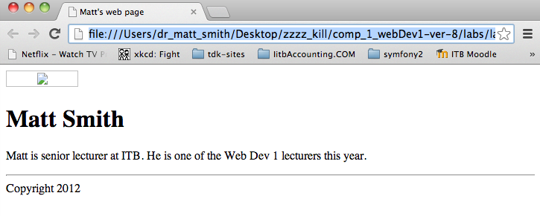

**Exercise 1-E:**

There was one problem though wasn’t there? The image did not appear …. We’ll fix this in this exercise.

1. Create a folder named images in your lab01 folder.
2. Go to the Moodle page for the course and download the file matt.jpg, saving the image into folder /lab01/images
3. Reload the matt.html web page in your web browser.

The image should appear correctly now.

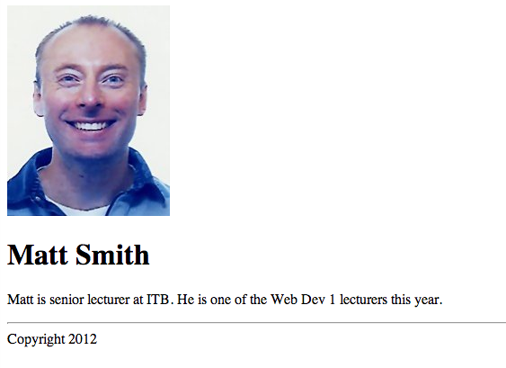

**Exercise 1-F:**

The next thing to do is add a style sheet for some simple presentation on the page.

First you create a file containing style rules, then add a statement in your HTML file to ask the browser to load and follow the styles rules from the stylesheet file.

1. In your editor create a new, empty text file, and type in the following CSS code
2. Create a folder named css in your lab01 folder.
3. Then save this file as style.css into folder /lab01/css

**/* this file is: style.css */**

**body {**

**background-color: yellow;**

**}**

**h1 {**

**color: green;**

**}**

**p {**

**font-size: small;**

**font-family: sans-serif;**

**}**

**header {**

**text-align: right;**

**}**

Now add a statement in your HTML file to tell the broswer to read in and apply your style rules:

1. In your editor view your matt.html file.
2. After the closing title tag ( </title> ) make a new line and type the <style> line show here (so the first few lines of your HTML file should now look as shown):

<!doctype html>

<html lang=”en”>

<head>

<meta charset="utf-8">

<title>Matt's web page</title>

**<style>**

**@import "css/style.css";**

**</style>**

1. Save the file and view again in the browser.

You should see something like HTML with CSS web page shown in the week 1 lecture.

**Exercise 1-G:**

Change the colour scheme so that the heading is some other colour other than green.

HINT: You need to edit and save your **style.css** file in your editor

**Exercise 1-H:**

It’s not much use you having a web page about someone else is it? Do the following to make a web page about YOU:

1. Make a copy of the file and give it your name (i.e. if your name is Fred, then copy *matt.html* and rename the copied file *fred.html*).
2. In your editor edit the page so that all the information about Matt (e.g. title, heading and text) is replaced with information about YOU.

**Exercise 1-I:**

It’s still not great that there is a picture of Matt there on your page. We are going to grab a picture of someone else from the Internet, pretend it is you, and use it for the webpage (if you happen to have a digital picture of yourself handy instead then all the better).

1. Pick an image from <http://www.boblasky.com/headshots/>
   * Save the image to your lab01 folder. Right click and *Save Picture As...*
     1. Or take a selfie and email it to yourself and download on your computer …
     2. Or grab a photo from your website/blog/social media web page
2. Name the file *yourfirstname*.jpg, e.g. if your name is Brian call it brian.jpg.
3. Edit the HTML code for the <img> element, so it loads up brian.jpg   
   (or whatever your file is called) rather than matt.jpg

**SUMMARY**

You should now have the following file structure, and have 2 working web pages:

**web_dev_1\**

**lab01\**

**matt.html**

**yourname.html**

**css\**

**style.css**

**images\**

**matt.jpg**

**yourname.jpg**

**lab02\ etc.**

Well Done  
You have created webpages and stylesheets – You have begun your journey as a web developer ...